

Exploratory Data Analysis (EDA) Report Design for Agribusiness Trends

  - A report blueprint for a hypothetical agribusiness dataset.
Sanjay C
12 November 2026

Table of Contents
1 Introduction 3
1.1 Coverage of the assignment objectives 3
2 The Hypothetical Dataset 4
2.1 Packages and setup 4
3 Business Questions 4
4 Variables and Metrics Relevant to Agribusiness 5
4.1 Core variables 5
4.2 Derived metrics and KPIs 5
5 Types of Analyses Planned 6
6 EDA Methodology: Workflow from Raw Data to Insight 6
7 Simulating the Dataset 7
7.1 Data dictionary 9
8 Step 1: Profile and Clean the Data 9
9 Step 2: Univariate Analysis 11
10 Step 3: Regional Analysis 12
11 Step 4: Seasonal and Time-Series Analysis 14
11.1 Seasonal index 14
11.2 Trend, season and noise (STL decomposition) 15
11.3 Heatmap of month by year 15
11.4 Price volatility 16
12 Step 5: Price and Arrivals (Market Analysis) 17
13 Visualization Plan 18
14 Handling Statistical Anomalies 19
14.1 Worked example: why robust rules are needed 19
14.2 Classification and treatment 20
14.3 Applying the method to the dataset 20
14.4 Sensitivity analysis 22
15 Handling Feature Correlations 23
15.1 Pearson and Spearman 23
15.2 Correlation heatmap and multicollinearity (VIF) 23
15.3 Two traps: spurious trends and Simpson’s paradox 24
15.4 Rainfall and yield 25
16 Workflow Diagram 27
17 Proposed Structure of the Final EDA Report 28
17.1 Executive summary template 28
17.2 How each analysis section is written 29
18 Expected Outcomes 29
19 Industry Terminology 29
20 Tools and Reproducibility 30
20.1 Evidence of Execution in Posit Cloud 31
21 Risks and Mitigation 32
22 Conclusion 33

1 Introduction
Agribusiness decisions depend on patterns hidden in production, weather, input-cost and market data: what to plant, when to sell, where to build storage, and how to price. Exploratory Data Analysis (EDA) is the stage where those patterns are found and checked before any forecast, model or policy decision is made.
This document is a complete blueprint for an EDA report on agribusiness trends. It is written for R and RStudio, and every analysis is paired with the R code that implements it. It covers:
- the business questions and the variables and metrics relevant to agribusiness;
- the types of analyses to perform and the visualization techniques suited to each;
- how statistical anomalies and feature correlations are handled, with worked examples;
- a workflow diagram, and a reproducible R example on simulated data;
- the structure of the final EDA report (executive summary, methodology, analysis, recommendations);
- the expected outcomes of the EDA process.

1.1 Coverage of the assignment objectives
# | Assignment requirement | Where covered
1 | Complete outline of an EDA report on agribusiness trends | Sections on the report structure and workflow
2 | Turn raw data into actionable insights | EDA steps, worked example, recommendations
3 | Elaborate on types of analyses, visualization techniques, expected outcomes | Types of analyses, visualization plan, expected outcomes
4 | List and describe variables and metrics | Variables and metrics
5 | Plan visualizations for different datasets and insights | Visualization plan, worked charts
6 | Draft report sections (executive summary, methodology, analysis, recommendations) | Proposed structure of the final report
7 | Clarify handling of anomalies and feature correlations | Anomaly handling, correlation analysis

2 The Hypothetical Dataset
The blueprint assumes a district-level panel of state x crop x month, assembled from production statistics, market (mandi) price boards, weather services and input-cost indices.
Dataset | Typical fields | Granularity
Crop production | Area sown, production, yield, crop, season (Kharif / Rabi / Zaid) | District, annual
Market prices | Modal price (INR/quintal), min and max price, arrivals, market | Mandi, daily (aggregated monthly)
Weather | Rainfall, temperature, rainfall deviation from normal | District, monthly
Input costs | Fertilizer index, diesel price, wages | State, monthly
Policy and trade | MSP, export bans, subsidy flags | National or state, event-based

2.1 Packages and setup
library(tidyverse) # dplyr, ggplot2, tidyr, ...
library(lubridate) # dates
set.seed(2026) # fixed seed so the simulated data is reproducible
(Install once with install.packages("tidyverse").)

3 Business Questions
- Which regions and crops lead production, and how is yield per hectare changing over time?
- How strong and predictable are the seasonal cycles in arrivals and prices?
- How do rainfall, input costs and policy relate to yield and price?
- Where is price volatility highest, and which observations are anomalies?
- Which findings are reliable enough to act on, and which need predictive modelling?

4 Variables and Metrics Relevant to Agribusiness

4.1 Core variables
Category | Variables | Why it matters
Regional production | State, district, area sown, production, yield | Identifies production hubs and productivity gaps
Seasonal and temporal | Date, month, crop season, marketing year | Reveals planting, harvest and price cycles
Market prices | Modal price, min-max spread, arrivals | Shows price formation and volatility
Weather | Rainfall, temperature, dry-spell length | Main driver of yield and supply shocks
Input economics | Fertilizer index, diesel, wages, cost of cultivation | Drives farmer margins
Policy and external | MSP, export ban dummies, subsidy flags | Explains structural breaks

4.2 Derived metrics and KPIs
Metric | Formula | R implementation | Purpose
Yield | Production / Area | production / area_ha | Productivity
CAGR | (End / Start)^(1/years) - 1 | (last / first)^(1/n) - 1 | Growth trend
Seasonal index | Month average / overall average x 100 | 100 * avg / mean(avg) | Seasonality
Coefficient of variation | SD / mean | sd(x) / mean(x) | Volatility and risk
Price spread | Max price - min price | max - min | Market efficiency
Gross margin per ha | Yield x price - cost | yield * price - cost | Profitability
Production share | Region output / total | x / sum(x) | Supply concentration
Price-to-MSP ratio | Modal price / MSP | price / msp | Policy pressure
A small worked example of three of these metrics (hypothetical numbers):
tibble(production_t = c(1200, 1500), area_ha = c(300, 320)) %>%
mutate(yield_t_ha = round(production_t / area_ha, 2))
## # A tibble: 2 × 3
## production_t area_ha yield_t_ha
## <dbl> <dbl> <dbl>
## 1 1200 300 4
## 2 1500 320 4.69
first <- 1000; last <- 1500; n_years <- 5
round((last / first)^(1 / n_years) - 1, 4) # CAGR = 8.45 percent per year
## [1] 0.0845
x <- c(1800, 2100, 2500, 1900)
round(sd(x) / mean(x), 3) # coefficient of variation
## [1] 0.149

5 Types of Analyses Planned
Analysis type | Techniques | Example question
Descriptive (univariate) | Mean, median, SD, quartiles, skewness | What is a typical price and how variable is it?
Regional (cross-sectional) | Ranking, production share, yield gap, ANOVA | Which states lag in yield for the same crop?
Temporal and seasonal | Rolling average, CAGR, STL decomposition, seasonal index | When do prices peak each year?
Market and price | Volatility (CV), arrival-price link, price vs MSP | How much do supply surges depress price?
Relationship analysis | Correlation, lagged correlation, clustering | Does rainfall relate to yield?
Anomaly analysis | IQR, z-score, MAD, residual checks | Which records are errors, and which are real shocks?

6 EDA Methodology: Workflow from Raw Data to Insight
Step | Goal | R tools | Decision rule
1 | Profile the data | glimpse(), summary(), colSums(is.na()) | Record the baseline row and column counts
2 | Clean and standardise | mutate(), recode(), parse_number() | One unit and one label per concept
3 | Integrate sources | left_join() | Check for unmatched keys after every join
4 | Univariate analysis | summarise(), geom_histogram() | Check shape, skew, spread
5 | Regional analysis | group_by(), geom_col() | Rank and compare states and crops
6 | Temporal and seasonal analysis | stl(), geom_line() | Separate trend, season and noise
7 | Relationship analysis | cor(), geom_point(), lm() | Treat results as associations
8 | Anomaly review | IQR, z-score, MAD | Flag first, decide with domain knowledge
9 | Synthesise insights | Tables, charts, text | Each finding needs evidence and an action
10 | Report and reproduce | R Markdown, renv, set.seed() | Anyone can rerun and get the same result

7 Simulating the Dataset
The simulated data has 5 states, 3 crops and 10 years (2015 to 2024). It deliberately contains problems found in real data (unit errors, missing values and a genuine price shock), so the cleaning and anomaly steps have something to find.
states <- c("Tamil Nadu", "Punjab", "Maharashtra", "Uttar Pradesh", "Karnataka")
crops <- c("Rice", "Wheat", "Onion")
# Weather is generated once per state and month (all crops in a state share the same weather)
dates <- seq(as.Date("2015-01-01"), by = "month", length.out = 120)
weather <- expand_grid(state = states, date = dates) %>%
mutate(
month = as.integer(format(date, "%m")),
rainfall_mm = pmax(0, 100 + 90 * sin((month - 3) / 12 * 2 * pi) + rnorm(n(), 0, 35)),
temp_c = 27 + 5 * sin((month - 4) / 12 * 2 * pi) + rnorm(n(), 0, 1)
) %>%
select(state, date, rainfall_mm, temp_c)
# Fertilizer cost index is national, so it is also generated once per month
fert <- tibble(date = dates) %>%
mutate(t = (as.integer(format(date, "%Y")) - 2015) + as.integer(format(date, "%m")) / 12,
fert_index = 100 * 1.05^t * exp(rnorm(n(), 0, 0.03))) %>%
select(date, fert_index)
agri_raw <- expand_grid(state = states, crop = crops, date = dates) %>%
left_join(weather, by = c("state", "date")) %>%
left_join(fert, by = "date") %>%
mutate(
year = as.integer(format(date, "%Y")),
month = as.integer(format(date, "%m")),
t = (year - 2015) + month / 12,
peak = case_when(crop == "Rice" ~ 11, crop == "Wheat" ~ 4, TRUE ~ 3),
scale = case_when(state == "Punjab" ~ 1.6, state == "Uttar Pradesh" ~ 1.4,
state == "Maharashtra" ~ 1.1, state == "Tamil Nadu" ~ 0.8, TRUE ~ 0.7),
arrivals_t = scale * 500 * (1 + 0.6 * cos((month - peak) / 12 * 2 * pi)) * exp(rnorm(n(), 0, 0.15)),
base = case_when(crop == "Rice" ~ 2000, crop == "Wheat" ~ 2100, TRUE ~ 1500),
vol = ifelse(crop == "Onion", 0.18, 0.06),
price_inr_qtl = base * 1.05^t * (arrivals_t / (scale * 500))^-0.35 * exp(rnorm(n(), 0, vol))
) %>%
select(state, crop, date, year, month, rainfall_mm, temp_c, fert_index, arrivals_t, price_inr_qtl)
# Annual production table
rain_year <- weather %>%
mutate(year = as.integer(format(date, "%Y"))) %>%
group_by(state, year) %>%
summarise(rain_year = sum(rainfall_mm), .groups = "drop")
production <- expand_grid(state = states, crop = crops, year = 2015:2024) %>%
left_join(rain_year, by = c("state", "year")) %>%
mutate(
area_ha = round(case_when(state == "Punjab" ~ 300000, state == "Uttar Pradesh" ~ 350000,
state == "Maharashtra" ~ 220000, state == "Tamil Nadu" ~ 150000,
TRUE ~ 120000) * runif(n(), 0.85, 1.15)),
base_yield = case_when(crop == "Rice" ~ 2.8, crop == "Wheat" ~ 3.1, TRUE ~ 16),
yield_tha = base_yield * (1 + 0.015 * (year - 2015)) *
(1 + 0.0004 * (rain_year - mean(rain_year))) * exp(rnorm(n(), 0, 0.05)),
production_t = area_ha * yield_tha
) %>%
select(-base_yield)
# Inject typical problems
N <- nrow(agri_raw)
bad <- sample(N, 12)
agri_raw$price_inr_qtl[bad] <- agri_raw$price_inr_qtl[bad] * 100 # unit errors
agri_raw$price_inr_qtl[sample(setdiff(1:N, bad), 25)] <- NA # missing prices
agri_raw$arrivals_t[sample(1:N, 40)] <- NA # missing arrivals
spike <- agri_raw$crop == "Onion" & agri_raw$state == "Maharashtra" &
agri_raw$year == 2019 & agri_raw$month %in% 9:11
agri_raw$price_inr_qtl[spike] <- agri_raw$price_inr_qtl[spike] * 2.2 # genuine flood shock

7.1 Data dictionary
Variable | Meaning | Unit
state, crop | Region and commodity | -
date, year, month | Time keys | -
rainfall_mm, temp_c | Monthly rainfall and mean temperature | mm, degrees C
fert_index | Fertilizer cost index | index
arrivals_t | Market arrivals | tonnes
price_inr_qtl | Modal market price | INR per quintal
area_ha, yield_tha, production_t | Area, yield, production | ha, t/ha, tonnes
rain_year | Annual rainfall of the state (sum of its 12 monthly values) | mm

8 Step 1: Profile and Clean the Data
dim(agri_raw)
## [1] 1800 10
glimpse(agri_raw)
## Rows: 1,800
## Columns: 10
## $ state <chr> "Tamil Nadu", "Tamil Nadu", "Tamil Nadu", "Tamil Nadu", …
## $ crop <chr> "Rice", "Rice", "Rice", "Rice", "Rice", "Rice", "Rice", …
## $ date <date> 2015-01-01, 2015-02-01, 2015-03-01, 2015-04-01, 2015-05…
## $ year <int> 2015, 2015, 2015, 2015, 2015, 2015, 2015, 2015, 2015, 20…
## $ month <int> 1, 2, 3, 4, 5, 6, 7, 8, 9, 10, 11, 12, 1, 2, 3, 4, 5, 6,…
## $ rainfall_mm <dbl> 40.278331, 17.210823, 104.873334, 142.033793, 154.609900…
## $ temp_c <dbl> 22.96214, 22.49174, 24.50329, 27.51162, 29.04394, 31.119…
## $ fert_index <dbl> 101.29117, 103.06645, 101.21419, 100.28836, 105.20685, 9…
## $ arrivals_t <dbl> 439.1407, 306.5846, 257.7221, 135.1808, 185.5799, 172.93…
## $ price_inr_qtl <dbl> 1940.846, 2064.459, 2177.602, 2761.303, 2639.475, 2691.9…
colSums(is.na(agri_raw)) # missing values per column
## state crop date year month
## 0 0 0 0 0
## rainfall_mm temp_c fert_index arrivals_t price_inr_qtl
## 0 0 0 40 25
summary(agri_raw$price_inr_qtl) # the maximum is far too high: unit errors
## Min. 1st Qu. Median Mean 3rd Qu. Max. NAs
## 703.9 2038.1 2484.6 4202.6 3021.4 447597.3 25
Cleaning follows two rules: unit errors are corrected (a price more than 20 times the crop median is almost certainly in the wrong unit), and gaps are filled with the median of the same state, crop and calendar month.
agri <- agri_raw %>%
group_by(crop) %>%
mutate(unit_error = !is.na(price_inr_qtl) & price_inr_qtl > 20 * median(price_inr_qtl, na.rm = TRUE)) %>%
ungroup() %>%
mutate(price_inr_qtl = ifelse(unit_error, price_inr_qtl / 100, price_inr_qtl)) %>%
group_by(state, crop, month) %>%
mutate(price_inr_qtl = ifelse(is.na(price_inr_qtl), median(price_inr_qtl, na.rm = TRUE), price_inr_qtl),
arrivals_t = ifelse(is.na(arrivals_t), median(arrivals_t, na.rm = TRUE), arrivals_t)) %>%
ungroup()
c(unit_errors_fixed = sum(agri$unit_error), missing_left = sum(is.na(agri$price_inr_qtl)))
## unit_errors_fixed missing_left
## 12 0
Cleaning action | Rule | Result in this dataset
Correct unit errors | Price above 20 x crop median is divided by 100 | 12 prices corrected
Fill missing prices | Median of same state, crop, month | 25 gaps filled
Fill missing arrivals | Median of same state, crop, month | 40 gaps filled
Keep genuine shocks | Not removed; flagged in the anomaly step | 2019 onion spike kept

9 Step 2: Univariate Analysis
agri %>%
group_by(crop) %>%
summarise(mean = mean(price_inr_qtl), median = median(price_inr_qtl),
sd = sd(price_inr_qtl), cv = sd / mean,
min = min(price_inr_qtl), max = max(price_inr_qtl)) %>%
mutate(across(where(is.numeric), ~ round(., 2)))
## # A tibble: 3 × 7
## crop mean median sd cv min max
## <chr> <dbl> <dbl> <dbl> <dbl> <dbl> <dbl>
## 1 Onion 2096. 1986. 664. 0.32 704. 5582.
## 2 Rice 2728. 2632. 628. 0.23 1608. 5078.
## 3 Wheat 2866. 2767. 682. 0.24 1625. 5294.
ggplot(agri, aes(price_inr_qtl)) +
geom_histogram(bins = 40, fill = "darkgreen", colour = "white") +
facet_wrap(~ crop, scales = "free") +
labs(title = "Price distribution by crop", x = "Price (INR/quintal)", y = "Count") +
theme_minimal()
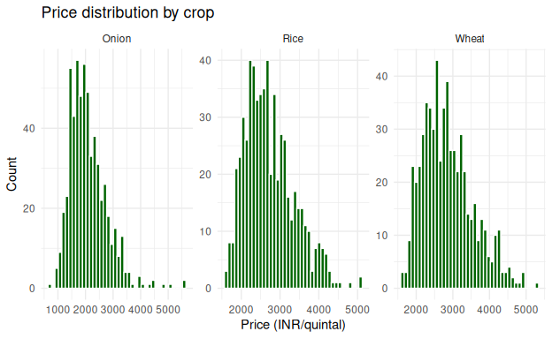
Reading the chart: onion prices are right-skewed with a long upper tail (price spikes). Rice and wheat are tighter. Right-skewed variables are candidates for a log transform before modelling.

10 Step 3: Regional Analysis
regional <- production %>%
group_by(state) %>%
summarise(production_t = sum(production_t), .groups = "drop") %>%
mutate(share_pct = round(100 * production_t / sum(production_t), 1)) %>%
arrange(desc(production_t))
regional
## # A tibble: 5 × 3
## state production_t share_pct
## <chr> <dbl> <dbl>
## 1 Uttar Pradesh 82563330. 30.8
## 2 Punjab 72474225. 27.1
## 3 Maharashtra 50750805. 19
## 4 Tamil Nadu 34458849. 12.9
## 5 Karnataka 27510988. 10.3
ggplot(regional, aes(reorder(state, production_t), production_t / 1e6)) +
geom_col(fill = "darkgreen") + coord_flip() +
labs(title = "Total production 2015-2024 by state", x = NULL, y = "Million tonnes") +
theme_minimal()
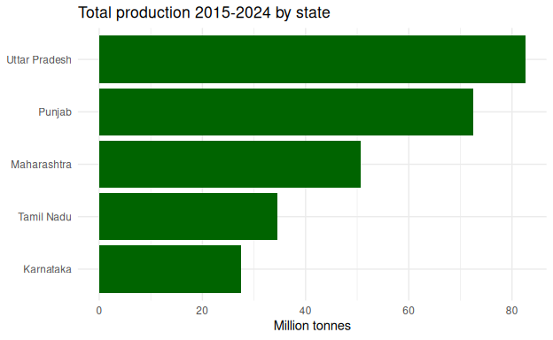
ggplot(production, aes(state, yield_tha, fill = state)) +
geom_boxplot(show.legend = FALSE) +
facet_wrap(~ crop, scales = "free_y") +
labs(title = "Yield by state and crop", x = NULL, y = "Yield (t/ha)") +
theme_minimal() +
theme(axis.text.x = element_text(angle = 35, hjust = 1))
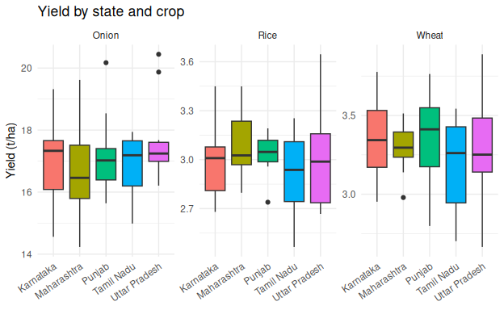
Decision use: the bar chart ranks supply concentration; the box plots show yield gaps between states for the same crop, which is the starting point for extension and irrigation planning.

11 Step 4: Seasonal and Time-Series Analysis

11.1 Seasonal index
The seasonal index is the average price of a calendar month divided by the overall average, times 100. A value of 120 means prices in that month run 20 percent above the annual average.
seasonal <- agri %>%
group_by(crop, month) %>%
summarise(avg = mean(price_inr_qtl), .groups = "drop") %>%
group_by(crop) %>%
mutate(seasonal_index = 100 * avg / mean(avg)) %>%
ungroup()
ggplot(seasonal, aes(month, seasonal_index, colour = crop)) +
geom_hline(yintercept = 100, linetype = "dashed") +
geom_line(linewidth = 1) + geom_point() +
scale_x_continuous(breaks = 1:12, labels = month.abb) +
labs(title = "Seasonal price index (100 = annual average)", x = NULL, y = "Index", colour = "Crop") +
theme_minimal()
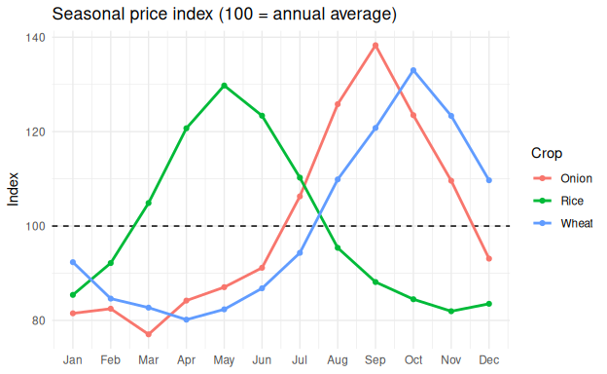

11.2 Trend, season and noise (STL decomposition)
onion <- agri %>% filter(crop == "Onion") %>%
group_by(date) %>% summarise(price = mean(price_inr_qtl), .groups = "drop")
onion_ts <- ts(onion$price, start = c(2015, 1), frequency = 12)
plot(stl(onion_ts, s.window = "periodic"), main = "STL decomposition of average onion price")
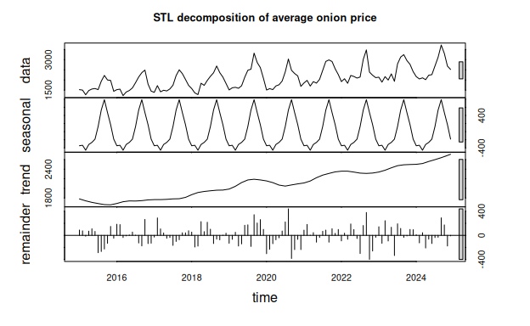
The decomposition separates a long-run trend, a repeating seasonal pattern, and a remainder. Large values in the remainder point to shocks that seasonality and trend cannot explain, which links this step to the anomaly review.

11.3 Heatmap of month by year
agri %>%
filter(crop == "Onion") %>%
group_by(year, month) %>%
summarise(price = mean(price_inr_qtl), .groups = "drop") %>%
ggplot(aes(factor(month, labels = month.abb), factor(year), fill = price)) +
geom_tile() +
scale_fill_viridis_c() +
labs(title = "Onion price by month and year", x = NULL, y = NULL, fill = "INR/qtl") +
theme_minimal()
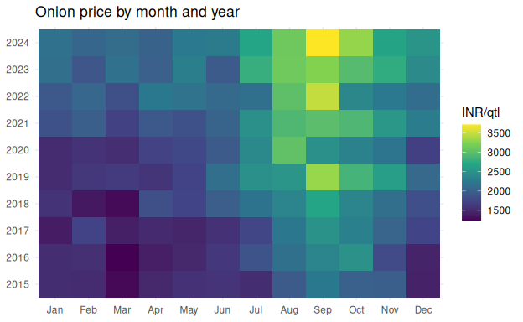

11.4 Price volatility
agri %>%
group_by(crop, year) %>%
summarise(cv = sd(price_inr_qtl) / mean(price_inr_qtl), .groups = "drop") %>%
ggplot(aes(year, cv, colour = crop)) +
geom_line(linewidth = 1) + geom_point() +
labs(title = "Price volatility (coefficient of variation) by year", x = NULL, y = "CV") +
theme_minimal()
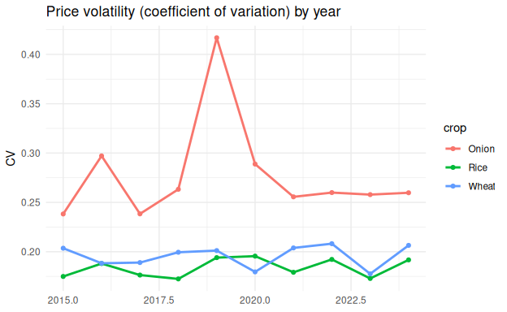

12 Step 5: Price and Arrivals (Market Analysis)
ggplot(agri, aes(arrivals_t, price_inr_qtl)) +
geom_point(alpha = 0.3, colour = "darkgreen") +
geom_smooth(method = "lm", se = FALSE, colour = "red") +
facet_wrap(~ crop, scales = "free") +
scale_x_log10() + scale_y_log10() +
labs(title = "Higher arrivals, lower prices (log-log)",
x = "Arrivals (tonnes, log scale)", y = "Price (INR/quintal, log scale)") +
theme_minimal()
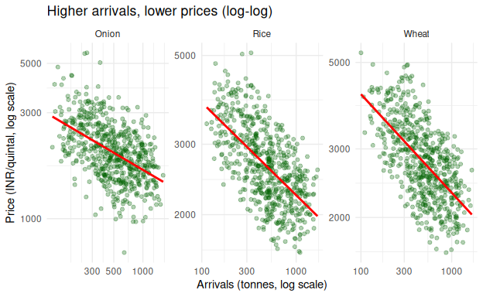
On a log-log scale the slope of the line is an elasticity: the percent change in price for a one percent change in arrivals. A negative slope confirms that supply surges depress prices.

13 Visualization Plan
Chart type | Variables | Insight delivered | Stage
Histogram / density | Yield, price, arrivals | Shape, skew, spread | Univariate
Box / violin plot | Yield or price by state or crop | Median, dispersion, outliers | Group comparison
Sorted bar chart | Production by state | Ranking and share | Regional
Stacked bar chart | Crop mix by region | Composition | Regional
Line chart | Monthly price over years | Trend, seasonality, shocks | Temporal
Heatmap (month x year) | Price | Recurring peaks and troughs | Temporal
Scatter plot with trend line | Yield vs rainfall; price vs arrivals | Direction and strength | Bivariate
Pair plot | Yield, rainfall, temperature, cost | Multi-variable screening | Multivariate
Correlation heatmap | All numeric variables | Correlated clusters | Multivariate
Choropleth map | Yield by district | Spatial hotspots | Regional
Decomposition plot | Price series | Trend, season, remainder | Temporal
Control chart | Price with +/- 2 SD band | Abnormal volatility | Anomaly
Design rules: label every axis with units, keep one colour per crop across all charts, write the title as the takeaway, and avoid 3D effects.

14 Handling Statistical Anomalies
An extreme value is either a data error (a unit mistake) or a genuine event (a flood or an export ban). The principle is: flag first, investigate, then decide, and document every decision.

14.1 Worked example: why robust rules are needed
x <- c(4.1, 4.5, 3.9, 4.8, 5.0, 4.3, 450, 4.6, 1.9) # yields in t/ha; 450 is an error
z <- (x - mean(x)) / sd(x) # classic z-score
mod_z <- 0.6745 * (x - median(x)) / mad(x, constant = 1) # modified z-score (median and MAD)
q <- quantile(x, c(0.25, 0.75)); iqr <- q[2] - q[1]
tibble(yield = x,
z_score = round(z, 2),
modified_z = round(mod_z, 1),
flag_z = abs(z) > 3,
flag_modz = abs(mod_z) > 3.5,
flag_iqr = x < q[1] - 3 * iqr | x > q[2] + 3 * iqr)
## # A tibble: 9 × 6
## yield z_score modified_z flag_z flag_modz flag_iqr
## <dbl> <dbl> <dbl> <lgl> <lgl> <lgl>
## 1 4.1 -0.33 -0.7 FALSE FALSE FALSE
## 2 4.5 -0.33 0 FALSE FALSE FALSE
## 3 3.9 -0.33 -1 FALSE FALSE FALSE
## 4 4.8 -0.33 0.5 FALSE FALSE FALSE
## 5 5 -0.33 0.8 FALSE FALSE FALSE
## 6 4.3 -0.33 -0.3 FALSE FALSE FALSE
## 7 450 2.67 751. FALSE TRUE TRUE
## 8 4.6 -0.33 0.2 FALSE FALSE FALSE
## 9 1.9 -0.35 -4.4 FALSE TRUE TRUE
The huge value of 450 inflates both the mean and the standard deviation, so its own z-score stays below 3 (with 9 values a z-score cannot exceed 2.67). This is called masking. The median, MAD and IQR are barely affected, so the robust rules flag the error correctly. They also flag 1.9 t/ha, a low but possible yield (for example in a drought year). A flag is therefore a prompt for review, not an automatic deletion: the 450 is set to missing because it is impossible for rice, while the 1.9 is kept if rainfall or other fields explain it.
Method | Best for | Weakness
z-score (above 3) | Roughly normal data, large samples | Masked by the outliers themselves
Modified z-score (above 3.5) | Skewed data, small samples | Needs enough variation in the data
IQR rule (1.5 or 3 x IQR) | General purpose, skewed data | Should be applied within groups
Residuals from STL | Time series with seasonality | Needs a fitted decomposition
Isolation Forest, Mahalanobis | Odd combinations of variables | Harder to explain to stakeholders
Domain rules | Impossible values (negative price) | Needs expert input

14.2 Classification and treatment
Type | Example | Treatment
Data entry or unit error | Price in INR/kg instead of INR/quintal | Correct from source; otherwise set to NA
Missing or placeholder value | 0 or 9999 for unreported | Convert to NA; impute by seasonal median
Genuine extreme event | Price spike after floods | Retain; add an event flag; report with and without
Structural break | Export ban, policy change | Retain; model periods separately or add a dummy
Isolated unexplained outlier | One market far from its neighbours | Winsorise or exclude, with a sensitivity check

14.3 Applying the method to the dataset
Anomalies are detected on the seasonally adjusted price (price divided by the median for the same state, crop and month), so ordinary seasonal peaks are not flagged.
anom <- agri %>%
group_by(state, crop, month) %>%
mutate(adj = price_inr_qtl / median(price_inr_qtl)) %>%
group_by(state, crop) %>%
mutate(q1 = quantile(adj, 0.25), q3 = quantile(adj, 0.75), iqr = q3 - q1,
anomaly = adj > q3 + 1.5 * iqr | adj < q1 - 1.5 * iqr) %>%
ungroup()
anom %>% count(crop, anomaly)
## # A tibble: 6 × 3
## crop anomaly n
## <chr> <lgl> <int>
## 1 Onion FALSE 581
## 2 Onion TRUE 19
## 3 Rice FALSE 596
## 4 Rice TRUE 4
## 5 Wheat FALSE 594
## 6 Wheat TRUE 6
anom %>% filter(anomaly) %>% arrange(desc(adj)) %>%
select(state, crop, date, price_inr_qtl, adj) %>% head(10)
## # A tibble: 10 × 5
## state crop date price_inr_qtl adj
## <chr> <chr> <date> <dbl> <dbl>
## 1 Tamil Nadu Onion 2023-03-01 3142. 2.26
## 2 Maharashtra Onion 2019-11-01 5040. 2.22
## 3 Maharashtra Onion 2019-10-01 5582. 2.09
## 4 Maharashtra Onion 2019-09-01 5536. 2.02
## 5 Karnataka Onion 2023-10-01 4282. 1.92
## 6 Punjab Onion 2024-11-01 3515. 1.92
## 7 Tamil Nadu Onion 2024-10-01 4422. 1.90
## 8 Karnataka Onion 2023-12-01 3344. 1.84
## 9 Tamil Nadu Onion 2024-03-01 2557. 1.84
## 10 Uttar Pradesh Onion 2023-01-01 2583. 1.76
anom %>%
filter(crop == "Onion", state == "Maharashtra") %>%
ggplot(aes(date, price_inr_qtl)) +
geom_line(colour = "grey40") +
geom_point(data = function(d) filter(d, anomaly), colour = "red", size = 2) +
labs(title = "Onion prices in Maharashtra: flagged anomalies in red",
subtitle = "The 2019 cluster is a genuine flood shock, so it is retained and labelled",
x = NULL, y = "INR/quintal") +
theme_minimal()
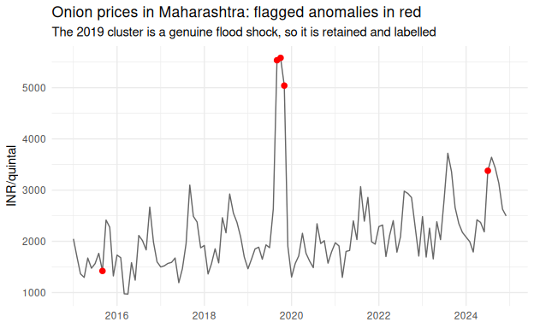

14.4 Sensitivity analysis
Key statistics are recomputed with and without the flagged points. If conclusions change materially, the report must say so.
bind_rows(
with_anomalies = anom %>% filter(crop == "Onion", state == "Maharashtra") %>%
summarise(mean_price = mean(price_inr_qtl), sd_price = sd(price_inr_qtl)),
without_anomalies = anom %>% filter(crop == "Onion", state == "Maharashtra", !anomaly) %>%
summarise(mean_price = mean(price_inr_qtl), sd_price = sd(price_inr_qtl)),
.id = "scenario"
) %>% mutate(across(where(is.numeric), ~ round(., 1)))
## # A tibble: 2 × 3
## scenario mean_price sd_price
## <chr> <dbl> <dbl>
## 1 with_anomalies 2132. 762.
## 2 without_anomalies 2043 547.
Compare the two rows: the flagged points (mainly the 2019 flood shock) raise both the mean and the standard deviation, so they explain much of the volatility. This is why the report states results with and without genuine events instead of silently deleting them.

15 Handling Feature Correlations

15.1 Pearson and Spearman
Pearson measures linear association and is sensitive to outliers. Spearman uses ranks, so it measures monotonic association and is robust to outliers and skew.
set.seed(1)
a <- rnorm(30)
b <- a + rnorm(30, 0, 0.5)
b[30] <- 25 # one extreme value
c(pearson = round(cor(a, b), 2), spearman = round(cor(a, b, method = "spearman"), 2))
## pearson spearman
## 0.27 0.86

15.2 Correlation heatmap and multicollinearity (VIF)
cd <- agri %>% filter(crop == "Rice") %>%
select(price_inr_qtl, arrivals_t, rainfall_mm, temp_c, fert_index)
cm <- cor(cd, method = "spearman")
round(cm, 2)
## price_inr_qtl arrivals_t rainfall_mm temp_c fert_index
## price_inr_qtl 1.00 -0.63 0.56 0.40 0.55
## arrivals_t -0.63 1.00 -0.61 -0.41 0.06
## rainfall_mm 0.56 -0.61 1.00 0.73 -0.03
## temp_c 0.40 -0.41 0.73 1.00 0.01
## fert_index 0.55 0.06 -0.03 0.01 1.00
as.data.frame(as.table(cm)) %>%
ggplot(aes(Var1, Var2, fill = Freq)) +
geom_tile(colour = "white") +
geom_text(aes(label = round(Freq, 2)), size = 3) +
scale_fill_gradient2(low = "red", mid = "white", high = "darkgreen", limits = c(-1, 1)) +
labs(title = "Spearman correlation (Rice)", x = NULL, y = NULL, fill = "rho") +
theme_minimal()
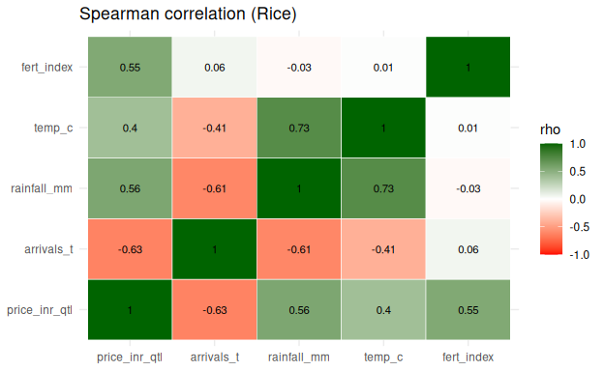
# Variance Inflation Factor in base R: VIF = 1 / (1 - R-squared of one predictor on the others)
vars <- c("arrivals_t", "rainfall_mm", "temp_c", "fert_index")
vif <- sapply(vars, function(v) {
r2 <- summary(lm(reformulate(setdiff(vars, v), response = v), data = cd))$r.squared
round(1 / (1 - r2), 2)
})
vif
## arrivals_t rainfall_mm temp_c fert_index
## 1.47 2.69 2.16 1.01
A VIF above 5 to 10 means a variable is largely explained by the others. The remedies are to drop one of a redundant pair, combine them into an index, or use PCA.

15.3 Two traps: spurious trends and Simpson’s paradox
Trap 1: two trending series correlate even if unrelated. Fertilizer cost and prices both rise with inflation, so their levels correlate strongly. Correlate the changes instead.
set.seed(1)
tt <- 1:60
a <- 100 * 1.05^(tt / 12) * exp(rnorm(60, 0, 0.02))
b <- 50 * 1.04^(tt / 12) * exp(rnorm(60, 0, 0.02))
c(levels = round(cor(a, b), 2),
changes = round(cor(diff(log(a)), diff(log(b))), 2))
## levels changes
## 0.92 0.05
The correlation of levels is high only because both series trend upward; the correlation of changes is close to zero.
Trap 2: Simpson’s paradox. A relationship across all data can reverse within each group.
set.seed(2)
sim <- tibble(group = rep(c("A", "B"), each = 20),
x = c(rnorm(20, 2, 0.5), rnorm(20, 6, 0.5))) %>%
mutate(y = ifelse(group == "A", 10, 20) - x + rnorm(40, 0, 0.5))
cor(sim$x, sim$y) # pooled: positive
## [1] 0.8699154
sim %>% group_by(group) %>% summarise(r = round(cor(x, y), 2)) # within groups: negative
## # A tibble: 2 × 2
## group r
## <chr> <dbl>
## 1 A -0.62
## 2 B -0.86
Risk | Safeguard
Correlation is not causation | Word findings as associations; name confounders (season, region, inflation)
Spurious trend correlation | Use differenced, detrended or inflation-adjusted data
Simpson’s paradox | Check relationships within regions and crops
Many tests, false positives | Multiple-testing correction; report effect sizes and intervals

15.4 Rainfall and yield
ggplot(production, aes(rain_year, yield_tha)) +
geom_point(alpha = 0.5, colour = "darkgreen") +
geom_smooth(method = "lm", colour = "red") +
facet_wrap(~ crop, scales = "free_y") +
labs(title = "Yield and annual rainfall", x = "Annual rainfall (mm)", y = "Yield (t/ha)") +
theme_minimal()
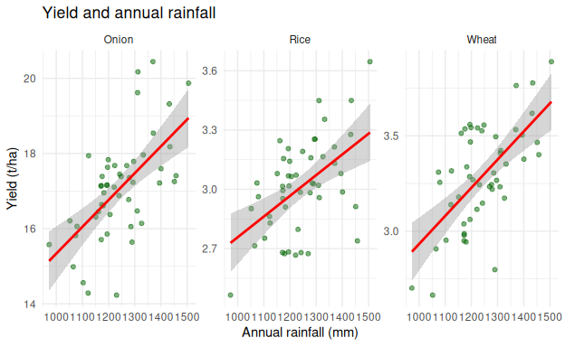
production %>% group_by(crop) %>%
summarise(spearman_rho = round(cor(rain_year, yield_tha, method = "spearman"), 2))
## # A tibble: 3 × 2
## crop spearman_rho
## <chr> <dbl>
## 1 Onion 0.62
## 2 Rice 0.46
## 3 Wheat 0.55
The Spearman correlations of 0.46 to 0.62 show a moderate positive association between annual rainfall and yield: wetter years tend to have higher yields, but the scatter in the chart shows that rainfall explains only part of the variation. This is an association, not proof of cause, because yield also rises with time and differs between states.

16 Workflow Diagram
The green boxes are data preparation and the blue boxes are analysis and reporting.
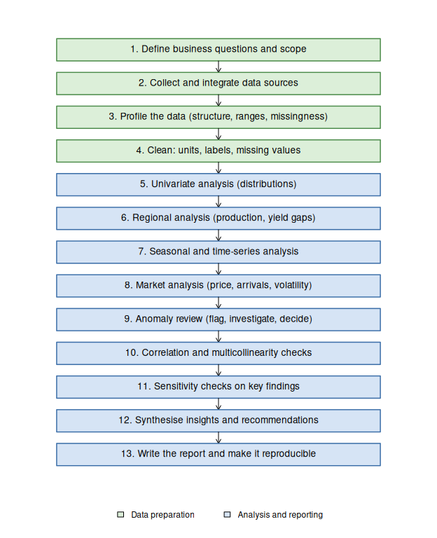
Figure 1: Proposed EDA workflow
If a sensitivity check (step 11) changes a conclusion, the workflow returns to the anomaly review or cleaning step, so the process is iterative.

17 Proposed Structure of the Final EDA Report
Section | Content | Length
Title page and contents | Title, author, date, dataset version | 1 page
1. Executive Summary | Objective, data used, 4 to 6 headline findings with numbers, top recommendations, caveats | 1-2 pages
2. Introduction and Objectives | Business context, questions, scope, stakeholders | 1 page
3. Data Description | Sources, coverage, variables and units, data dictionary, limitations | 2 pages
4. Methodology | Cleaning rules, imputation, anomaly treatment, statistical tests, tools | 2-3 pages
5. Data Quality Assessment | Missingness, duplicates, outliers, before and after cleaning | 1-2 pages
6. Exploratory Analysis | Regional production; seasonal trends; prices and volatility; weather and cost relationships | 8-12 pages
7. Correlation and Anomaly Findings | Correlation matrix, multicollinearity, anomalies and their causes | 2 pages
8. Key Insights | Synthesis linking findings to business meaning | 1-2 pages
9. Recommendations | Prioritised actions with owner, impact and confidence | 1-2 pages
10. Limitations and Next Steps | Data gaps, assumptions, predictive modelling plan | 1 page
Appendices | Code, extra charts, anomaly log, glossary | As needed

17.1 Executive summary template
Each headline finding follows the pattern Finding, Evidence, Implication, Action.
Finding | Evidence | Implication | Action
Onion prices peak well above the annual mean in the lean season | Seasonal index chart | Selling at harvest loses margin | Expand cold storage and stagger sales
Higher arrivals lead to lower prices | Price vs arrivals chart | Supply surges cause distress selling | Plan procurement with arrival forecasts
Production is concentrated in a few states | Regional bar chart | Supply risk is concentrated | Diversify sourcing and logistics
Yield rises with rainfall, with scatter | Rainfall vs yield chart | Weather explains part of the variation | Promote irrigation in low-yield states

17.2 How each analysis section is written
- State the question and why it matters to the business.
- Show a chart or table with a takeaway title.
- Interpret in plain language, with statistics and caveats.
- Link to the next section or to a recommendation.

18 Expected Outcomes
Outcome | Decision it supports
Ranked regional production and yield-gap view | Targeting extension, seed and irrigation investment
Monthly seasonal price indices | Best sowing, harvesting, storage and selling windows
Volatility and risk profile by crop | Pricing, hedging, insurance, working capital
Weather-yield and cost-margin relationships | Climate-risk planning and input purchase timing
Anomaly log and data-quality scorecard | Better data collection and trust in later models
Shortlist of strong predictors | Feature selection for price and yield forecasting

19 Industry Terminology
Term | Meaning
Mandi / APMC | Regulated agricultural wholesale market
MSP | Minimum Support Price set by government
Kharif / Rabi / Zaid | Monsoon, winter and summer crop seasons
Modal price | The most frequently quoted market price
Arrivals | Quantity of produce brought to a market
Yield gap | Difference between achievable and actual yield
Seasonal index | Ratio of a month’s average price to the annual average
Coefficient of variation | Variability relative to the mean
Basis | Local price minus a benchmark market price
Post-harvest loss | Share of produce lost between harvest and sale

20 Tools and Reproducibility
Reproducibility means anyone can rerun the same code on the same data and get the same results. In agribusiness this matters because recurring seasonal data needs the same treatment each year, decisions on loans or contracts may rest on the analysis, and reviewers must be able to see why a value was changed.
Need | Tool | Use in this project
Working environment | RStudio Project, here | One folder, relative paths
Import and cleaning | readr, dplyr, tidyr, lubridate | Read, recode, convert units, parse dates
Plots | ggplot2 | All charts in this report
Time series | stats::stl() | Decomposition and seasonal analysis
Reporting | R Markdown | Code, results and explanation in one document
Package versions | renv | renv::snapshot() writes renv.lock
Version control | Git and GitHub | Every change is committed
Randomness | set.seed() | Same simulated data on every run
Suggested project structure:
agribusiness-eda/
agribusiness-eda.Rproj
README.md <- how to run, data sources
renv.lock <- exact package versions
data/
raw/ <- original files, never edited
processed/ <- cleaned data and cleaning log
R/
cleaning_functions.R <- reusable functions
reports/
eda_report.Rmd <- this report
docs/
decision_log.md <- why each rule was chosen
install.packages("renv")
renv::init() # create a project library and renv.lock
renv::snapshot() # record package versions
renv::restore() # on another machine: install the exact versions
Reproducibility check | How to verify
Raw data unchanged | Keep raw files read-only; record a checksum in the README
No manual edits | Every change is a line of code
Same package versions | renv::status() reports no drift
Randomness controlled | set.seed() at the top
Decisions documented | Decision log and cleaning log kept with the report

20.1 Evidence of Execution in Posit Cloud
The report was built and knitted in an RStudio project on Posit Cloud. The screenshots below show the working environment: the production data frame in the data viewer (annual rainfall between about 970 and 1,500 mm), the data frames created in the R session together with the project files (the R Markdown source eda.Rmd and the knitted Word output eda.docx), and the console with the loaded packages.
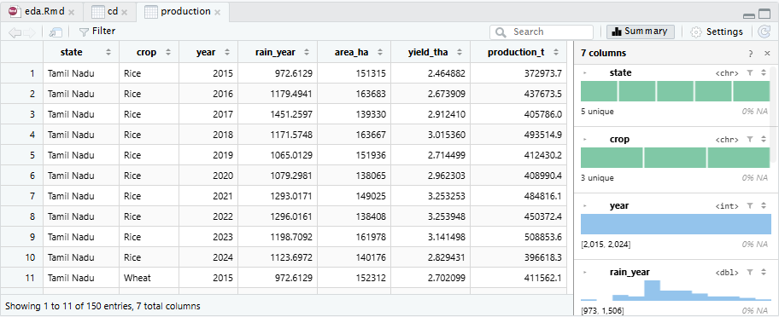
Figure : The production data frame (150 rows, 7 columns) in the RStudio data viewer
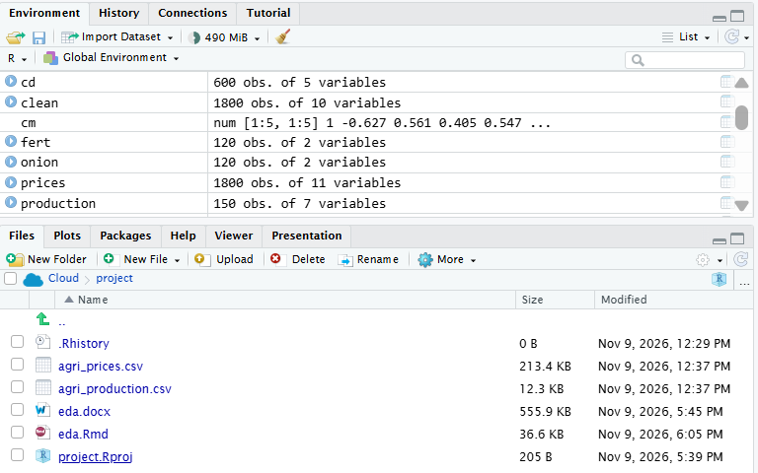
Figure : Environment pane (data frames in the session) and Files pane (eda.Rmd, eda.docx and project files)
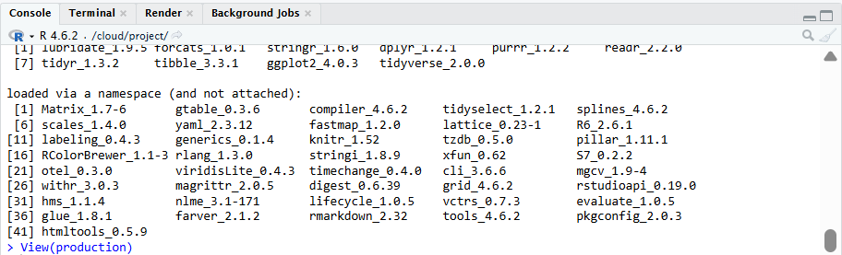
Figure : R console showing R 4.6.2 and the loaded packages (tidyverse 2.0.0, ggplot2 4.0.3)

21 Risks and Mitigation
Risk | Consequence | Mitigation
Over-aggressive outlier removal | Real shocks such as droughts are erased | Flag first, review, keep plausible extremes
Imputation bias | Variance underestimated | Group-wise imputation; report share imputed
Inconsistent region names or boundaries | Wrong joins and comparisons | Master mapping table; check unmatched keys
Sparse data in small markets | Unstable estimates | Aggregate; state uncertainty
Over-interpreting associations | Wrong decisions | Cautious wording; check confounders; sensitivity analysis
Stale data | Findings go out of date | Scripted, refreshable pipeline

22 Conclusion
This blueprint treats EDA as a structured, ordered process: define the business questions, prepare the data, analyse distributions, regions, seasons and markets, review anomalies with robust methods, check correlations for traps such as spurious trends and Simpson’s paradox, and then turn validated findings into recommendations. The worked R examples show that each step can be written as code, checked and repeated. A clear report structure, a documented set of decisions and a reproducible environment mean that the same conclusions can be rebuilt each season and traced back to the raw data.
The data used here are simulated, so the findings illustrate the method; real conclusions require the same workflow on actual production, market and weather data.
sessionInfo() # record R and package versions used for this report
## R version 4.6.2 (2026-10-29)
## Platform: x86_64-pc-linux-gnu
## Running under: Ubuntu 24.04.5 LTS
##
## Matrix products: default
## BLAS: /usr/lib/x86_64-linux-gnu/openblas-pthread/libblas.so.3
## LAPACK: /usr/lib/x86_64-linux-gnu/openblas-pthread/libopenblasp-r0.3.26.so; LAPACK version 3.12.0
##
## locale:
## [1] LC_CTYPE=C.UTF-8 LC_NUMERIC=C LC_TIME=C.UTF-8
## [4] LC_COLLATE=C.UTF-8 LC_MONETARY=C.UTF-8 LC_MESSAGES=C.UTF-8
## [7] LC_PAPER=C.UTF-8 LC_NAME=C LC_ADDRESS=C
## [10] LC_TELEPHONE=C LC_MEASUREMENT=C.UTF-8 LC_IDENTIFICATION=C
##
## time zone: UTC
## tzcode source: system (glibc)
##
## attached base packages:
## [1] stats graphics grDevices utils datasets methods base
##
## other attached packages:
## [1] lubridate_1.9.5 forcats_1.0.1 stringr_1.6.0 dplyr_1.2.1
## [5] purrr_1.2.2 readr_2.2.0 tidyr_1.3.2 tibble_3.3.1
## [9] ggplot2_4.0.3 tidyverse_2.0.0
##
## loaded via a namespace (and not attached):
## [1] Matrix_1.7-6 gtable_0.3.6 compiler_4.6.2 tidyselect_1.2.1
## [5] splines_4.6.2 scales_1.4.0 yaml_2.3.12 fastmap_1.2.0
## [9] lattice_0.23-1 R6_2.6.1 labeling_0.4.3 generics_0.1.4
## [13] knitr_1.52 pillar_1.11.1 RColorBrewer_1.1-3 tzdb_0.5.0
## [17] rlang_1.3.0 utf8_1.2.6 stringi_1.8.9 xfun_0.62
## [21] S7_0.2.2 otel_0.3.0 viridisLite_0.4.3 timechange_0.4.0
## [25] cli_3.6.6 mgcv_1.9-4 withr_3.0.3 magrittr_2.0.5
## [29] digest_0.6.39 grid_4.6.2 rstudioapi_0.19.0 hms_1.1.4
## [33] nlme_3.1-171 lifecycle_1.0.5 vctrs_0.7.3 evaluate_1.0.5
## [37] glue_1.8.1 farver_2.1.2 rmarkdown_2.32 tools_4.6.2
## [41] pkgconfig_2.0.3 htmltools_0.5.9

